Lesson 18: Thai

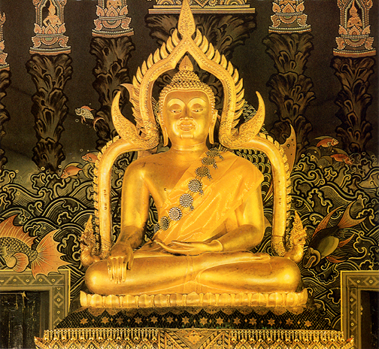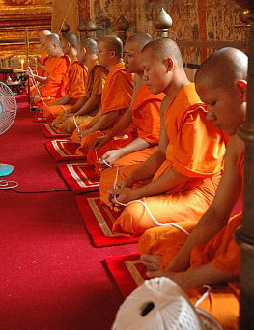

WHO are they? Among the Thai people, there is almost no division of labor by gender. That means both men and women pitch in to do the fishing, cooking, tilling, taking care of babies, cleaning the home and washing clothes.

The actual lifestyle of the Thai people varies a great deal, depending on people’s occupation. From rural farmers to merchants to the clergy, there are many differences among Thai people. The wealthiest Thai live in very nice houses with plank floors and tile roofs, while the poorest villagers live in bamboo homes with thatched roofs and dirt floors.

There are many health problems in Thailand. Hepatitis, Malaria, and HIV are common.
WHERE do they live? The Thai live throughout Thailand.
HOW many? There are about 60 million Thai people.
WHAT do they worship? The main religion of Thai people is Theravada Buddhism. Almost all are devout followers of Buddha, who is considered “the enlightened one.” That means that they seek to eliminate suffering and improve their own future by earning merit in the pursuit of what they call perfect peace. They try to earn merit by doing all kinds of things – feeding monks, donating to temples and attending worship services. The Thai also sometimes incorporate their Buddhist beliefs with folk animism, which means they seek help by worshipping spirits and objects.
PRAYER needs:
- Pray that God would raise up workers to work among the Thai people.
- Pray that as missionaries share, God would give them the words to say to help the Thai understand the Gospel.
- Pray that as workers help with the Thai’s physical needs that doors would be opened to the Gospel.

