Lesson 6: Batangeuno

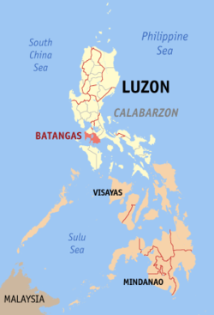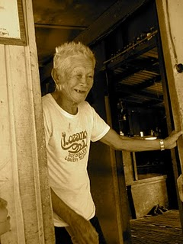

WHO are they? Long before the arrival of the Spaniards in the Philippines, large centers of population already thrived in Batangas. The present Batangueños are descendants of people from the island of Borneo. They organized the first Malay settlement at the mouth of the Taal River in the highlighted area below. Malay means a type of people. The Malay people all look similar. Today, the Malay people are mainly from Indonesia, Philippines and Malaysia. The Batangeuno are known to be brave warriors and heavy drinkers. They resisted the Spanish, the Japanese, and then the Americans. There has been a lack of trust to outside influence. This is now seen in being resistant to the gospel. While other tribes on the island have responded to the gospel, the Batangueno have remained hardened.

Where they live? They live in the province of Batangas on the island of Luzon in the Philippines.

WHAT do they worship? Batangenuos are known to be very religious. 98% would be Roman Catholic, but they practice many other beliefs such as wearing amulets for protection against evil spirits, and going to different kinds of spiritual healers.

PRAYER needs:
- More workers are needed that have a burden to share Christ and start new churches.
- More workers are needed that understand that the battle is spiritual.
- That Christians would be bold and have faith to pray for the sick and demonized.

